PRODUCT MANAGEMENT USING FASTAPI
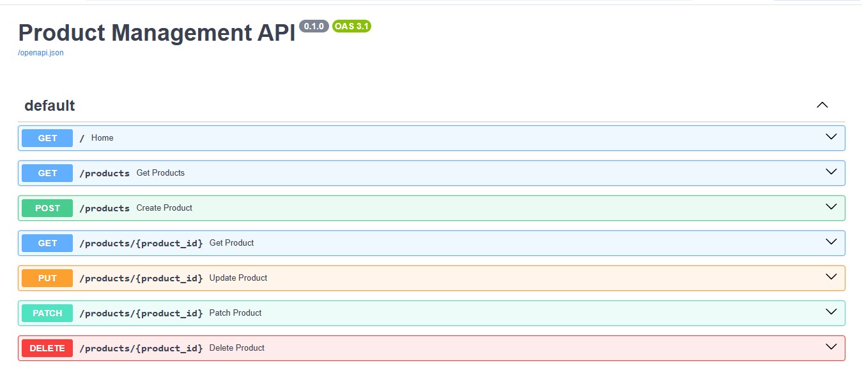
GET
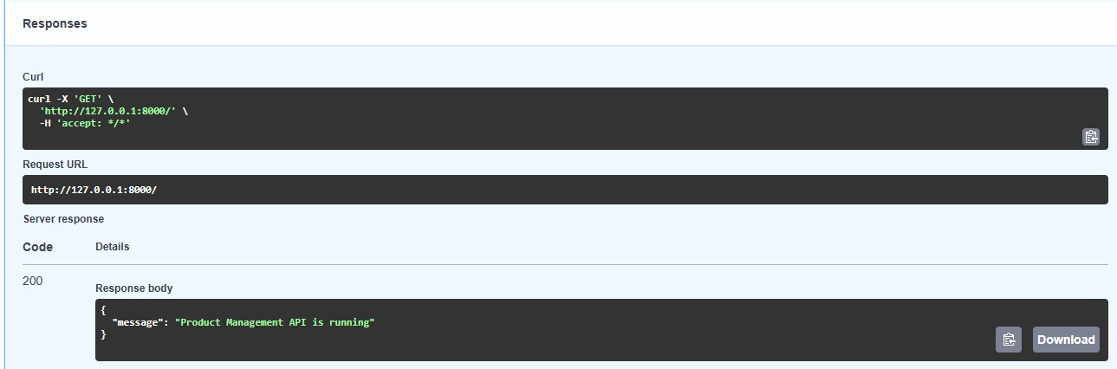
post
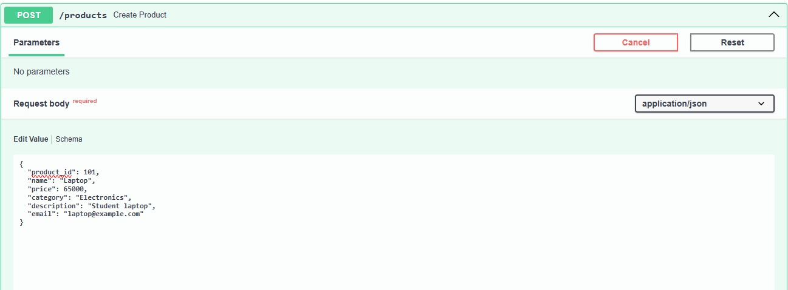
GET\PRODUCTS
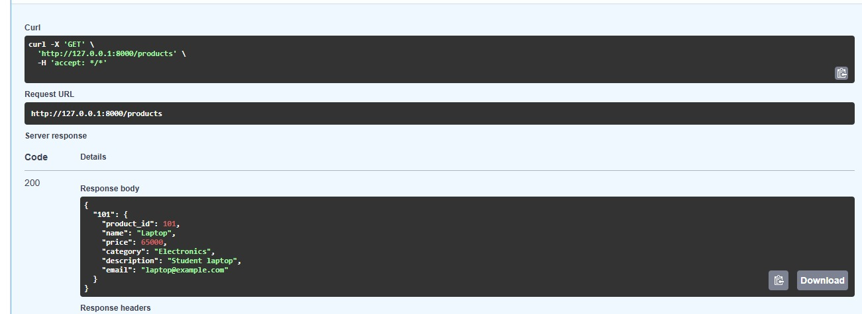
GET\PRODUCT\PRODUCT ID
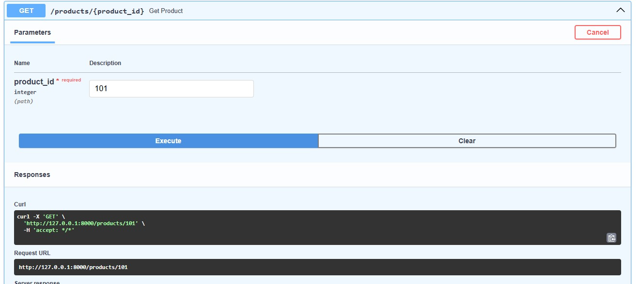
PUT\PRODUCT\PRODUCT ID
